Experiment 2

Aim:-
Implementation of Lexical Analyzer in C / Java / Python

Theory:-
Lexical Analyzer
A Lexical Analyzer, also called a lexer or scanner, is an important part of a compiler or interpreter. Its main job is to look at the source code written in a programming language and divide it into smaller parts called tokens. Tokens are like the building blocks of meaning in a programming language and can include things like keywords, names, numbers, symbols, and other specific language elements.
Functions of a Lexical Analyzer
- Tokenization: Breaking down the source code into smaller units called tokens. Tokens are the basic building blocks that represent meaningful elements in the programming language.
- Removal of Whitespace and Comments: Eliminating unnecessary spaces, tabs, and comments from the source code since they don't affect the program's logic.
- Identifying Keywords and Symbols: Recognizing and categorizing keywords, symbols, and operators that have predefined meanings in the programming language.
- Handling Identifiers: Identifying and managing variable names, function names, and other user-defined identifiers in the code.
- Dealing with Literals: Recognizing and handling constants or literals, such as numbers or strings, in the source code.

Significance of Lexical Analyzer
A lexical analyzer is important in the compilation process because it takes the messy raw source code and turns it into a more organized structure. This organized structure is easier for the parser (another part of the compiler) to work with. In a diagram showing how a compiler works, the lexical analyzer is usually the first step. This shows how it plays a key role in dealing with the source code and producing tokens as a result.
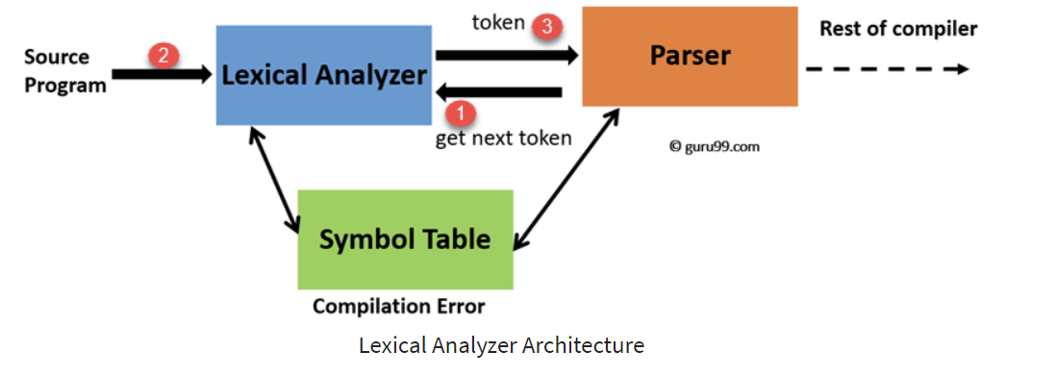

Role of Finite Automata in Lexical Analyzer:
In creating lexical analyzers, we often use something called Finite Automata. There are two types: Deterministic Finite Automata (DFA) and Non-deterministic Finite Automata (NFA). These automata are like step-by-step processes that help understand the rules of a programming language, described using things called regular expressions. Imagine these processes moving through different states depending on the characters they see in the code. This movement helps identify patterns in the code and break it down into smaller parts called tokens. It's a way of efficiently figuring out the meaning of different elements in the source code

Lexeme, Token, and Pattern:
- Lexeme:
A lexeme is like a group of characters in the code that matches a specific pattern for a token. For example, in the phrase "count = count + 1," the lexeme for the identifier token "count" is simply the word "count."
- Token:
A token is a bunch of lexemes that share the same pattern. Tokens are like the basic groups of meaning in a programming language. In the same phrase, we have different tokens like identifiers ("count"), the assignment operator ("="), and literals (like "1").
- Pattern:
The pattern is like a set of rules or instructions that tell us what a token should look like. For example, the pattern for an identifier in many programming languages might be something like [a-zA-Z_]\w*, which means it should start with a letter or underscore, followed by letters, digits, or underscores. It's like a blueprint for recognizing different types of things in the code.

Example:
Simple example in C:
int num = 10;
Lexeme for "int": "int"
Token: Keyword
Pattern for Keyword: "int"
Lexeme for "num": "num"
Token: Identifier
Pattern for Identifier: [a-zA-Z_]\w*
Lexeme for "=": "="
Token: Assignment Operator
Pattern for Assignment Operator: "="
Lexeme for "10": "10"
Token: Constant (Integer)
Pattern for Constant (Integer): \d+
In this example, lexemes represent the declaration and initialization of an integer variable. The tokens categorize these lexemes, and the patterns define the rules for recognizing each type of token.

Implementation:-
C File:
#include <stdio.h>
int main() {
printf("Hello, World!\n");

int num1 = 3;
int num2 = 10;
int sum = num1 + num2;

return 0;
}

Python File:
import re
def lexical_analyzer(input_code):
keywords = ['int', 'float', 'if', 'else', 'while', 'return', 'printf', 'scanf', 'main', 'sum', '\\n']
operators = ['+', '-', '*', '/', '=', '==', '!=', '<', '>', '.']
special_symbols = ['(', ')', '{', '}', ';', ',']
standard_files = ['stdio.h', 'stdio.c']
keyword_pattern = '|'.join(map(re.escape, keywords))
operator_pattern = '|'.join(map(re.escape, operators))
special_symbol_pattern = '|'.join(map(re.escape, special_symbols))
identifier_pattern = r'\b[a-zA-Z_][a-zA-Z0-9_]*(\.[a-zA-Z_][a-zA-Z0-9_]*)?\b|\b[a-zA-Z_][a-zA-Z0-9_]*\b'
directive_pattern = r'#\s*include'
standard_file_pattern = '|'.join(map(re.escape, standard_files))

pattern = f'({keyword_pattern})|({operator_pattern})|({identifier_pattern})|({special_symbol_pattern})|({directive_pattern})|({standard_file_pattern})'

tokens = re.findall(pattern, input_code)
tokens = [token for token in sum(tokens, ()) if token]
labeled_tokens = []
for token in tokens:
if token in keywords:
labeled_tokens.append(("Keyword", token))
elif token in operators:
labeled_tokens.append(("Operator", token))
elif re.match(directive_pattern, token):
labeled_tokens.append(("Directive", token))
elif token in special_symbols:
labeled_tokens.append(("Symbol", token))
elif token in standard_files:
labeled_tokens.append(("StandardFile", token))
elif re.match(identifier_pattern, token):
labeled_tokens.append(("Identifier", token))

return labeled_tokens
with open('sample.c', 'r') as file:
c_code = file.read()

output_tokens = lexical_analyzer(c_code)
print("Tokens")
for label, token in output_tokens:
print(f"{label}: {token}")

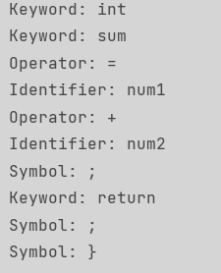
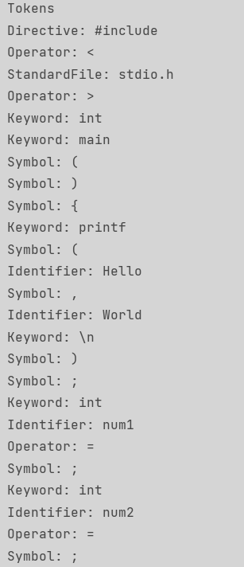

Conclusion:
Lexical analyzers involve efficiently recognizing and pulling out tokens from source code using tools like regular expressions and automata. Lexical analyzers are the first step in compiling code, helping organize it into clear token streams. This modular approach makes it easier for later stages of compilation to work with the code. Lexical analyzers also play a big role in finding errors, making the code run faster, and connecting with symbol tables for better performance. Formal methods and tools like Lex or Flex make the implementation process smoother. Understanding lexical analyzers is important for making strong compilers, allowing flexibility in language design, and making progress in building compilers.

